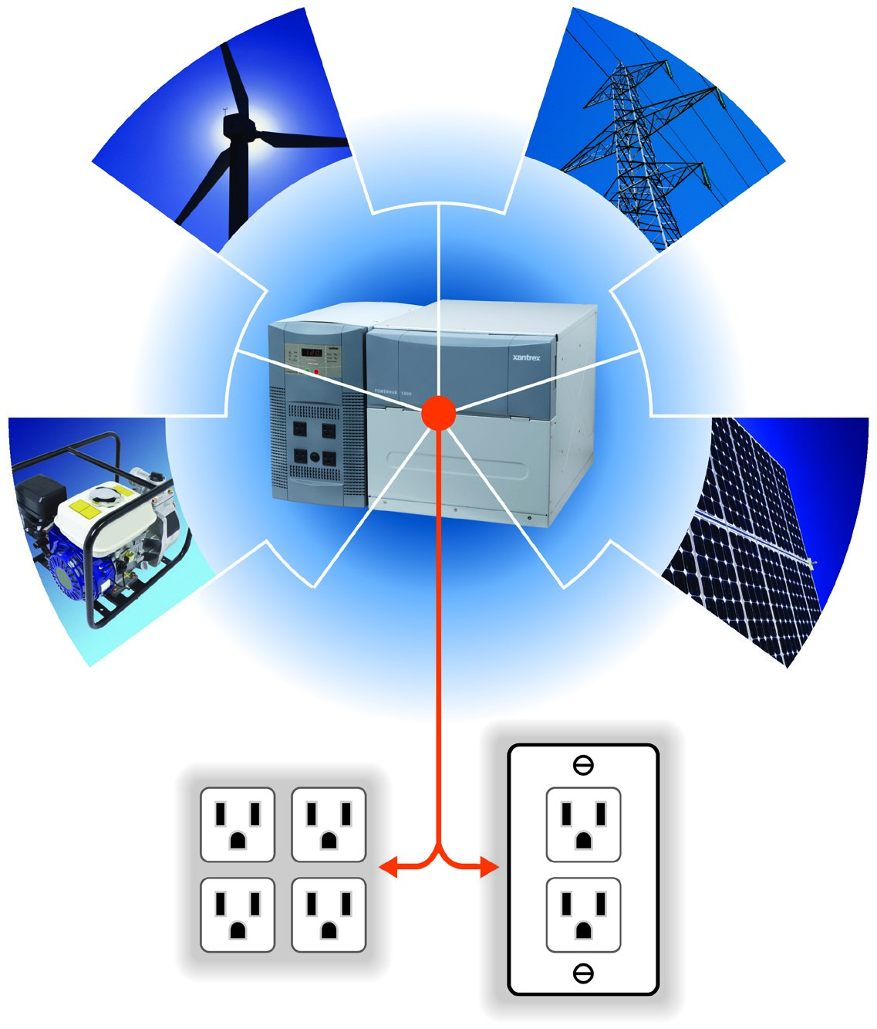

Solar Sun World PowerHub
Renewable
Backup Power System
Watts
1800
A Clean, Green, Backup Power Solution
The PowerHub is a combination of an inverter/charger module capable of delivering
up to 1800 watts of household power.
It is the first backup power solution to operate
with solar and wind inputs.
Power from a generator or the utility grid can also be used with
the PowerHub system to recharge its batteries. The PowerHub provides an affordable, high-
output, primary power solution for an off-grid cottage or cabin, as well as backup power for
grid-connected homes when the power goes out. It is scalable up to 400 amp-hours of energy,
allowing customers to build their system based on their power requirements.

Never worry about running out of power – renewable power sources, solar and wind, sustain

the PowerHub’s battery charge indefinitely

An excellent alternative to a generator – designed for indoor use, with no fuel, fumes or noise

Add it to a grid-tie solar energy system for backup power
Product Features

Modified sine wave inverter/charger with battery box

The battery box stores up to 200 amp-hours of battery power

(
single battery box included; batteries purchased separately
)

A second battery may be connected to double the battery capacity

(
additional battery box and batteries sold separately
)

Designed to include a generator as part of the system; generator power can pass

through the unit to the AC outlets, and recharge the batteries

Integrated transfer switch

40-
amp three-stage charger

Four AC outlets with hardwire option

Two DC inputs for solar and/or wind connections

Full-feature LED display for system monitoring
Solar Sun World

2701 Little River Road
Madison, Ga 30650
Office: 706-752-1682

Cell: 706-318-0784

jk@solarsunworld.com
www.solarsunworld.com

Battery Charger Specifications
Output current | 0/10/40 A
Output voltage
Charge | 14.2 Vdc
Float | 13.7 Vdc
Recharge | 12.5 Vdc
AC input voltage | 115 Vac 50/60 Hz
Charger efficiency | 80% approximate
Charging type | Three-stage

PowerHub 1800 Runtimes (single battery box with 200 AH battery)
Office Applications | Watts | Runtime
Laptop | 65 | 22 h
Inkjet printer | 8 | 218 h 20 min
Cell phone | 5 | 396 h
Table lamp | 25 | 54 h 45 min
17” LCD monitor | 35 | 49 h 50 min
Table light 40 W | 40 | 43 h
Table light 60 W | 60 | 26 h 40 min
Emergency Power Applications | Watts | Runtime
Cordless phone | 5 | 396 h
Clock radio | 8 | 218 h 20 min
13” CRT TV | 50 | 30 h 10 min
20” LCD TV | 370 | 3 h 20 min
Home Backup Power Applications | Watts | Runtime
18 cu. ft. fridge | 120 | 15 h 25 min
8.8 cu. ft. freezer | 80 | 20 h 20 min
Sump pump (1/2 hp) | 300 | 4 h 29 min
Home alarm system | 5 | 396 h
Microwave | 1000 | 1h 43 min
Coffee maker | 1200 | 1h

www.solarsunworld.com
706-752-1682
• jk@solarsunworld.com
€

